

GOVT. POLYTECHNIC, JHAJJAR [HR.]

WEBSITE DEVELOPMENT



**FINAL REPORT**

|  |  |
| --- | --- |
| AKASH | **190050820001** |
| **RAHUL KHATRI** | **19005080026** |
| **PUSHKAR** | **190050820014** |

**Table Of Content:-**

1). Introduction…………………………………………………………………………………….

2). Need of this project…………………………………………………………………………

3). Project planning………………………………………………………………………………

4). Idea to grow…………………………………………………………………………………..

5). Content sources………………………………………………………………………………

6). Design sources………………………………………………………………………………….

7). Overview………………………………………………………………………………………….

**INTRODUCTION**

Our website is for students <https://akashsrepositories.github.io/Polytechnic-Handnotes/> which perform a good work in diploma engineering (Computer science).

In this project, computer engineering 3rd semester,4th semester or 5th semester were covered. If our project on the grid of success than other semesters & streams will be covered in next project.

This project is useful for every student of computer engineering (diploma) who wants to carry good marks in exams and wants to learn things easily because our project gave idea to student how to learn things without huge stuff carry in mind through our handwritten notes.

**Why hand notes are better?**

Several studies have reported that although writing on a Paper saves time because it is a faster process, taking notes by hand improves students' memorization and word recognition. One of the advantages of handwritten notes is that reading and writing on paper improves conceptual understanding.

**NEED OF THIS PROJECT**

On our website, student can easily access the notes of every chapter, assignment and practical files of the specified semester of computer engineering.

Basically this project is very important from student view because it having most of things which did not found on single path.

It will be beneficial to every student of computer engineering to learn things easily. Here student could get the handwritten notes in a very well arranged manner.

**Project Planning**

As we are also students of Computer Engineering [B.TECH (diploma)]. While pursuing our diploma course we also felt some sort type of difficulties in arranging the notes and study material of every subject.

Our group discussed about this topic and after deep discussion finalized this for our project and decided to prepare a website for the upcoming students of engineering. We consulted it with our teachers and mentors and we got fully appreciation and support from their side.

As this not only help the students to prepare for their exams. Here students can learn things in a very easy way and get the study material in a well arranged manner.

**Idea to grow**

we know plants need fertilizer,sun,and the proper temperature to grow.As human,we need proper condition to grow as well.Students in a classroom depends on their teacher and college to help create a strong learning environment.As we got order,we become responsible for our own growth and learning.

Basically our project working on that environment which gave a proper mood to the student who wants to learning things.

Teachniques to improve study:-

1).Find a good study spot.

2).Take a break and take care of yourself.

3).Organize handnotes/lecture notes.

4).Leave time for the last minute review.

5).Aromatherapy,plants and music.

**Content sources**

When we working on the project than content create the huge problem because it the important aspect of our project and we would like to gave best study material to our viewers/seniors/juniors.Than we thought that why we gave good notes which was written by us.

Some more content provider:-

1. Handnotes by ourselves.
2. Taking advice from teachers and mentors.
3. Arrange study material from seniors/juniors.
4. By Greatful advices and directiors.
5. Internet and web services**.**

**Designing sources**

This project is well up maintained and classical perfect in any point of view that website is designed through the help of many references:-

Helping IDs and hosted application

1. **Visual studio code**

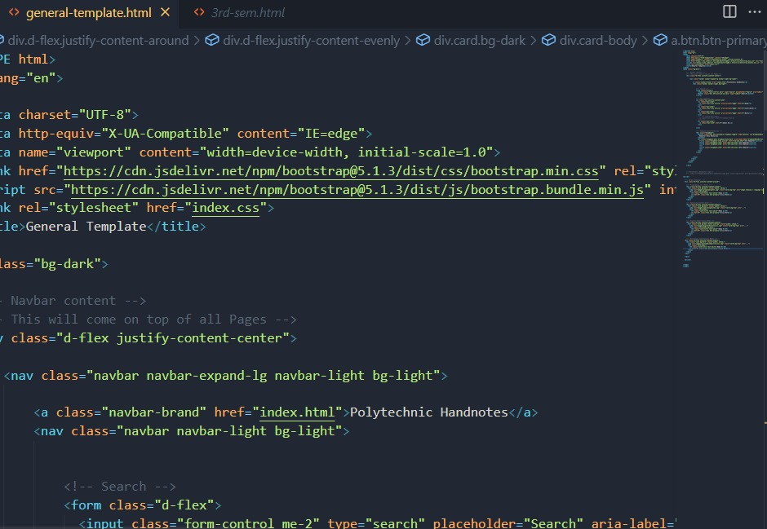

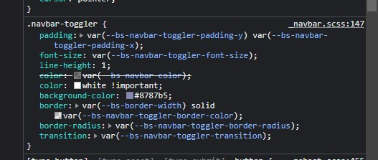

**Bootstrap**

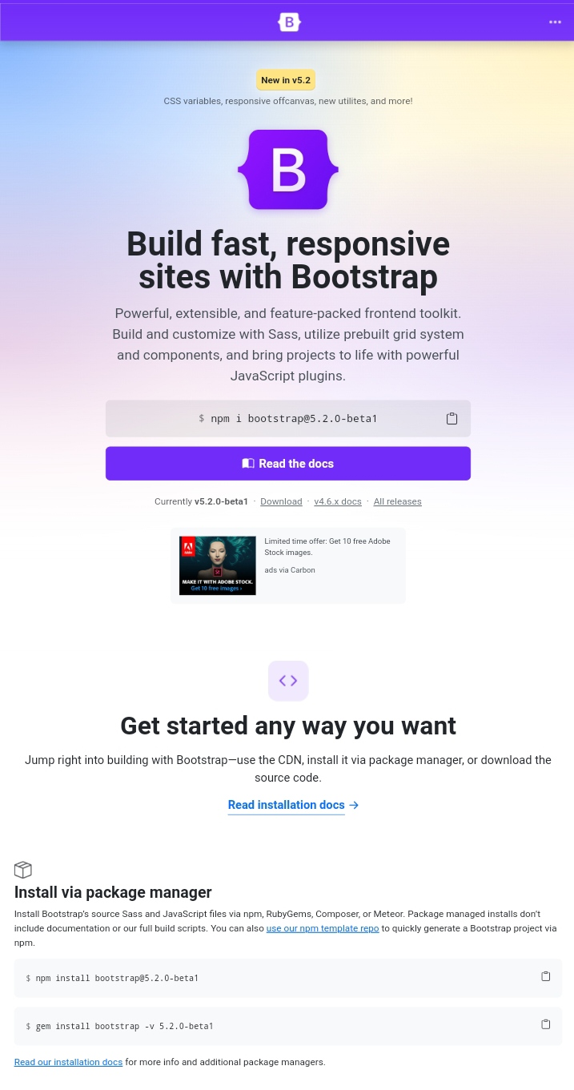

**Git Hub**

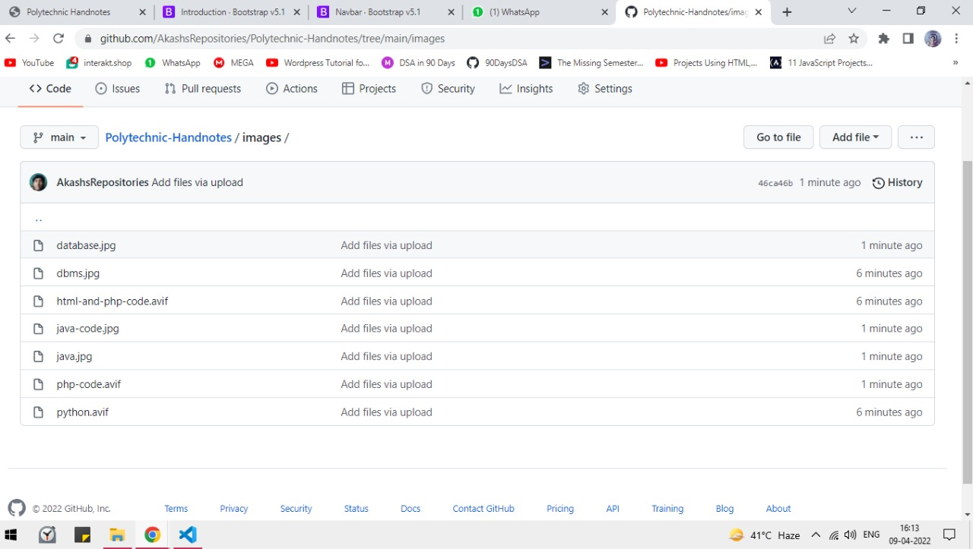

**Overview**

The site is fully designed for the easily accessibility of students. All the contents are arranged in a well manner and subject wise handnotes are provided to the students under semester-wise distribution.

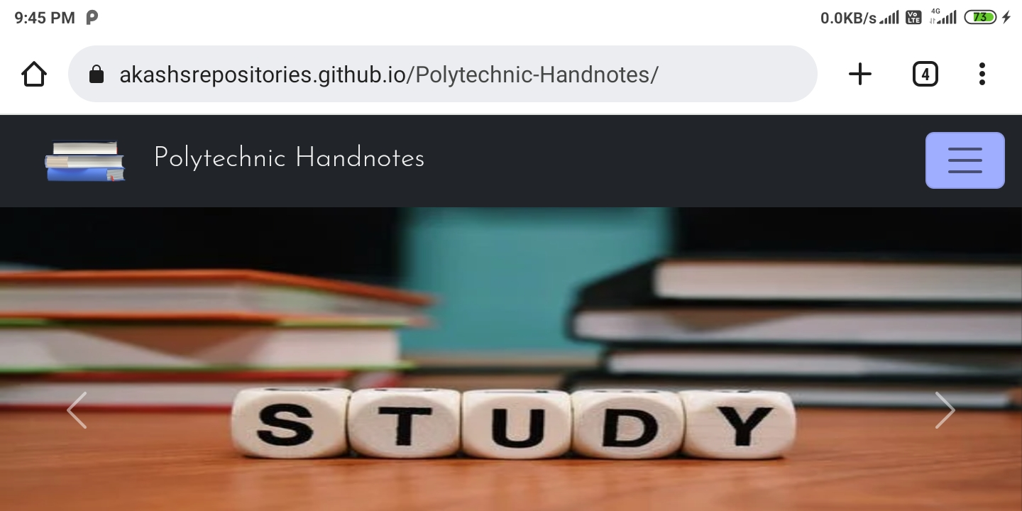**Home Page**

**Contents window**

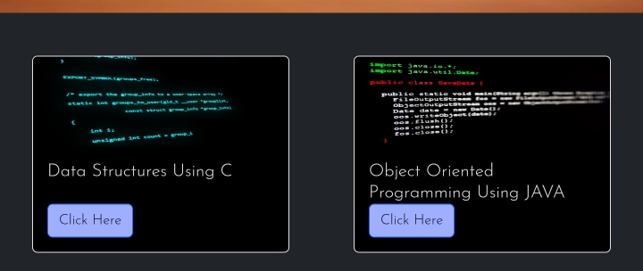

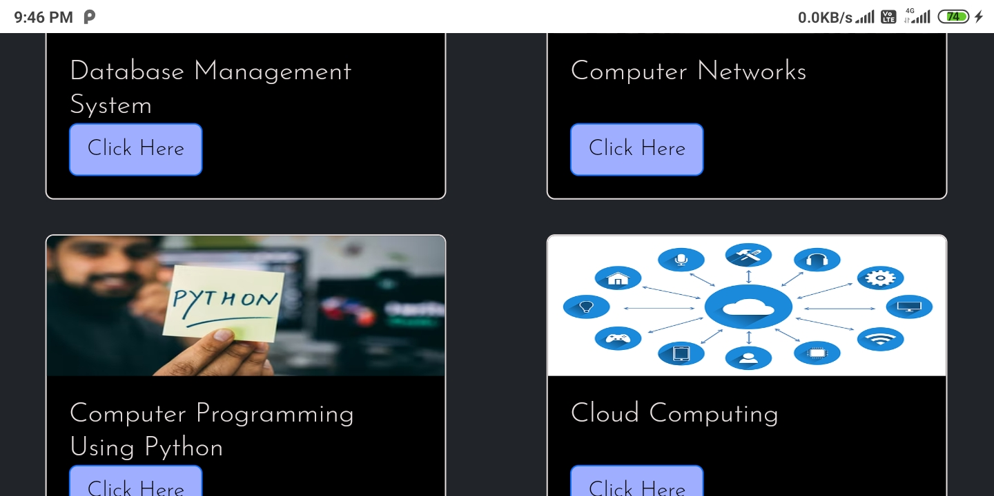

**About us**

